Simpsons 2 – Level Breakdown July 2, 2002

Episode as one our 6 character-based playing experiences.
Level: An area of the world that to the player seems like a continuous area that can be explored without waiting for a load to complete.
District: A sub-area of a level that has a distinct art design. A level contains multiple districts. A district contains multiple zones. This term is not used elsewhere in this document but is provided here so that we have a way to talk about level sub-areas that are logically separated because of art design, and level sub-areas that are logically separated because of visual occulsion and their role in the dynamic loading system.
Zone: A sub-area of a level that is visually occluded from all other parts of the level.
Interior: A small, indoor, detailed environment that can only be entered on foot and is detailed enough to require that they be loaded dynamically. An interior is exactly like a zone except that there is no visual occlusion between the interior and some parts of the zone in which it is located.
- Interior Landmarks
- Out-of-the-Car jumping Zone (loadable chunk)
- Priority
Loadable Chunk: A piece of world data that dynamically loads at one time. A loadable chunk is either a zone or an interior.
Load Trigger: A trigger volume, usually a sphere, that is located around a loadable chunk. When the player goes from outside a load trigger to inside one, the load of the associated loadable chunk is initiated.
Episode 1 – Suburbs (High Noon Day)
Episode 2 – Downtown (day)
Episode 3 – Seaside (night)
Episode 4 – Suburbs (Sunset evening)
Episode 5 – Downtown (night)
Episode 6 – Seaside (early sunrise)
Episode 7 – Suburbs (Halloween night)

Level One - Suburbs

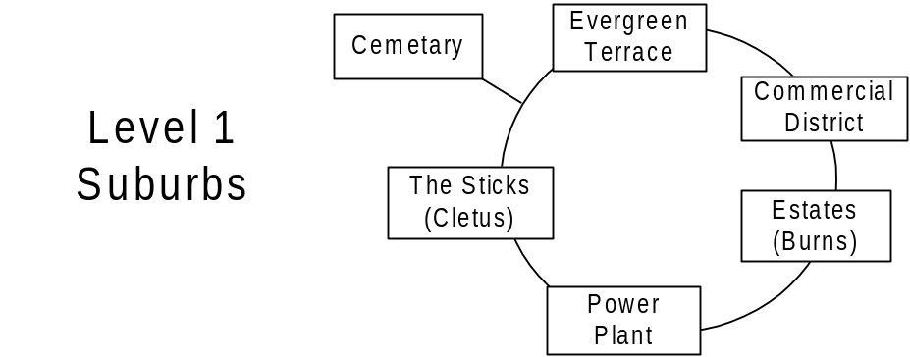
District 1 (Evergreen Terrace)
- Evergreen Terrace
  - Simpsons’ House (interior) (1)
  - Flanders’
  - Ruth Powers
  - Rev. Lovejoy
  - Lenny
  - Apu (with for sale sign)
- School
  - School (unlockable interior) (3)
  - Milhouse
  - Principle Skinner
  - Wiggam

District 2 (Commercial)
- Commercial
  - Krusty Burger
  - Gas Station
  - Kwik-E-Mart (interior) (2)
  - Lard Lads
- Church
  - Church
  - Retirement Castle (unlockable interior) (8)
  - Community Center

District 3 (Estates)
- Estates
  - House o’ Burlesque
  - Brockmans’
  - Krusty’s
  - Quimby Mansio
  - Malibu Stacy
- Burns Mansion (unlockable interior) (5)
  - Maze (out of car puzzle – loadable chunk) (7)

District 4 (Power Plant)
- Power Plant
  - Offices
  - Interior (out of car puzzle – loadable chunk) (6)
  - Interior (interior) (4)

District 5 (Sticks)
- Sticks
  - Nelsons House
  - Cletus’ House
  - Moe’s House

District 6 (Cemetery)
- Cemetery (bonus – loadable chunk)

Level Two - Downtown

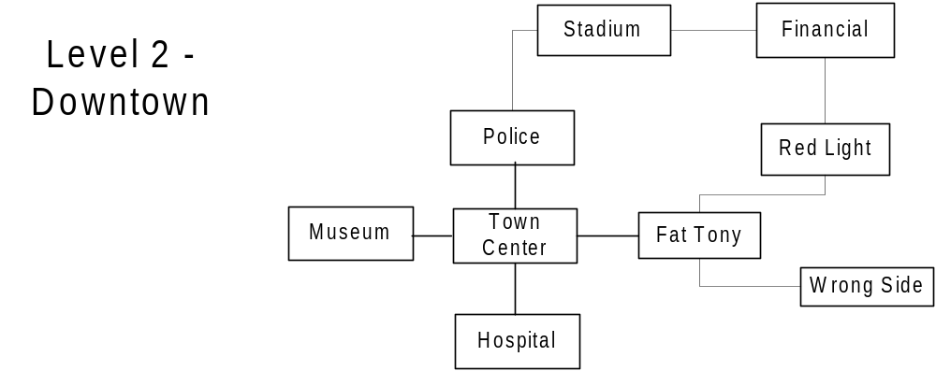
District 1 (Town Center)
- Town Square
  - Moes (interior) (1)
  - King Toots
  - Town Hall (unlockable interior) (5)
  - Post Office
  - Court House
  - Park
  - Zesty
  - Gas Station
  - DMV (interior) (7)
- Hospital (9)
  - Operation Room
- Police Station
  - Jail and Booking room (interior) (2)
- Museum of Natural Art
  - WWII exhibit
  - Dinosaur exhibit (unlockable interior) (3)
- Little Italy
  - Fat Tony’s

District 2 (Lower East Side)
- Wrong side of the Tracks
  - Plasma center
  - Helter Shelter
  - Veterans of Popular Wars
  - Herman’s Antiques (unlockable interior) (6)
  - Blood Bank
  - Car Wash
  - Krusty Burger
  - Gas Station
- Red-light District
  - She She
  - Horny Toad
  - Nudes @ 11
  - Adam and Adam
  - Girlesque

District 3 (Financial)
- Financial
  - Sit ‘n Rotate (unlockable interior)
  - Up & Up Buffet
  - Escalator to Nowhere
  - State Building
  - Parade
  - Magnifying Glass/Popsicle Sky Scraper
  - Construction sites (out of car puzzle – loadable chunk) (8)
- Stadium
  - Playing field (Truckasauras) (out of car puzzle – loadable chunk) (4)
  - Concourse

Level Three - Seaside

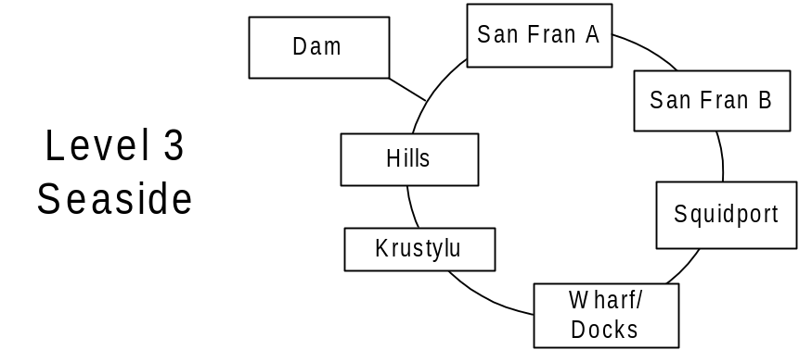

District 1 (Entertainment District)
- Scum (San Fran A)
  - No-Tell Motel
  - My 1st Tattoo
  - Gas Station
- Fun (San Fran B)
  - Noiseland Arcade (interior) (3)
  - Android’s Dungeon (interior) (1)
  - Wally Weasel
  - Bowl-a-Rama (7)
- Restaurants
  - Aztec
  - Happy Sumo
  - Rusty Barnacle
  - Singing Sirloiner
  - Chez Perri

District 2 (Squidport)
- Squidport
  - Planet Hype
  - Two guys from Kabul
  - Gilded Truffle

District 3 (Docks)
- Wharf
  - Ships (out of car puzzle – loadable chunk) (4)
  - Crates(out of car puzzle – loadable chunk)
  - Lighthouse (6)
- Krusty Lu
  - Krusty Stage (unlockable interior) (5)
  - Simpsons’ Stage
- Duff Brewery
  - Interior (unlockable interior) (2)

District 4 (Hills)
- Lower Hills (Hills A)
  - Observatory
  - Sign
- Upper Hills
  - Kamp Krusty
- Dam

